**Visvesvaraya Technological University**

**Belgaum-590014**



**A DBMS Mini-Project Report**

**On**

***“Airline Reservation System”***

*A Mini-project report submitted in partial fulfillment of the requirements for the award of the degree of* ***Bachelor of Engineering in Computer Science and Engineering*** *of Visvesvaraya Technological University, Belgaum.*

Submitted by:

**ASHWIN K S (1DT15CS013)**

**AND**

**KUSHAAL N KASHYAP(1DT15CS054)**

Under the Guidance of:

**Mr. RAGHU.M.T**

**(Asst. Prof. Dept of CSE)**



**Department of Computer Science and Engineering**

**DAYANADA SAGAR ACADEMY OF TECHNOLOGY AND MANAGAEMENT**

Kanakpura Road,Udayapura, Bangalore

2017-2018



**DAYANADA SAGAR ACADEMY OF TECHNOLOGY AND MANAGAEMENT,**

Kanakpura Road,Udayapura, Bangalore

**Department of Computer Science & Engineering**

**CERTIFICATE**

This is to certify that the Mini-Project on Database Management System (DBMS) entitled **“AIRLINE RESERVATION SYSTEM”** has been successfully carried out by **ASHWIN K S (1DT15CS013) and KUSHAAL N KASHYAP (1DT15CS054)** abonafide students of **Dayananda sagar academy of technology and management** in partial fulfillment of the requirements for the award of degree in **Bachelor of Engineering** **in Computer Science and Engineering** of **Visvesvaraya Technological University, Belgaum** during academic year 2017-2018. It is certified that all corrections/suggestions indicated for Internal Assessment have been incorporated in the report deposited in the departmental library. The mini project report has been approved as it satisfies the academic requirements in respect of project work for the said degree.

**GUIDES:**

|  |  |  |
| --- | --- | --- |
| **Mr. RAGHU.M.T** |  | **Mrs. JHANAVI S** |
| **(Asst. Prof. Dept of CSE)** |  | **(Asst. Prof. Dept of CSE)** |

**Dr. C. NANDINI**

**(Vice Principal & HOD, Dept. of CSE)**

**Examiners: Signature with Date**

**1:**

**2:**

**ACKNOWLEDGEMENT**

It gives us immense pleasure to present before you our project titled **‘AIRLINE RESERVATION SYSTEM USING HTML and PHP’.** The joy and satisfaction that accompany the successful completion of any task would be incomplete without the mention of those who made it possible. We are glad to express our gratitude towards our prestigious institution **DAYANANDA SAGAR ACADEMY OF TECHNOLOGY AND MANAGEMENT** for providing us with utmost knowledge, encouragement and the maximum facilities in undertaking this project.

We wish to express a sincere thanks to our respected principal **Dr. B. R. Lakshmikantha** for all their support.

We express our deepest gratitude and special thanks to **Dr.C.Nandini,** **Vice Principal &** **H.O.D, Dept. Of Computer Science Engineering**, for all her guidance and encouragement.

We sincerely acknowledge the guidance and constant encouragement of our mini- project guides, **Assistant Prof. Mr.Raghu. M.T.** and **Assistant Prof. Mrs.Jhanavi.S.**

**ASHWIN K S (1DT15CS013)**

**AND**

**KUSHAAL N KASHYAP (1DT15CS054)**

**ABSTRACT**

Our Project ‘Airline reservation System’ is a computerized system used to store and retrieve information and conduct transactions related to air travel. The aim the project is to expose the relevance and importance of Airline Reservation Systems.

The system allows the airline passenger to search for flights that are available between the two travel cities, namely the “Departure city” and “Arrival city” for a particular departure date. The system is designed such that flights are available on all days. The system displays all the flight’s details such as flight no, name, price etc.

Then the system checks for the availability of seats on the flight. If the seats are available then the system allows the passenger to book a seat. Otherwise it asks the user to choose another flight.

The system asks the customer to enter his details such as name, age, email and contact number to book a flight. The system also allows the customer to cancel his/her reservation, if any problem occurs.

The main purpose of this software is to reduce the manual errors involved in the airline reservation process and make it convenient for the customers to book the flights as and when they require. The software allows customer to make reservations, modify reservations or cancel a particular reservation.

**TABLE OF CONTENTS**

**Chapter # Chapter Name Page #**

**1 INTRODUCTION 1**

**1.1 Background 1**

**1.2 Problem Definition 1**

**1.3 Motivation 1**

**1.4 Objective 2**

**1.5 Scope of the project 2**

**2 REQUIREMENTS 3**

**2.1 Hardware Requirements 3**

**2.2 Software Requirements 3**

**3 DESIGN 4**

**3.1 Database Design 4**

3.1.1 E-R Diagram 4

3.1.2 Database Schema 5

3.1.3 Relational Schema 7

**3.2 Database Normalization 8**

3.2.1 First Normal Form 8

3.2.2 Second Normal Form 8

3.2.3 Third Normal Form 8

**3.3 User Interface 8**

3.3.1 User Registration Module 9

3.3.2 User Flight Search Module 10

3.3.3 Admin Registration Module 12

3.3.4 Admin Operations Module 13

**4 IMPLEMENTATION 15**

**4.1 User Registration Module 15**

**4.2 User Flight Search Module 16**

**4.3 Admin Registration Module 17**

**4.4 Admin Operations Module 18**

**4.5 Stored Procedure and Trigger 19**

**5 SOURCE CODE 20**

**6 CONCLUSION AND FUTURE WORK 24**

**6.1 Advantages 24**

**6.2 Future Enhancements 24**

**BIBLIOGRAPHY 25**

**LIST OF FIGURES**

**SL # FIGURE # TOPIC PAGE #**

1 Figure 3.1 User Registration Module 9

2 Figure 3.2 User Login 9

3 Figure 3.3 User Flight Search 10

4 Figure 3.4 Available Flights 10

5 Figure 3.5 Booking Details 11

6 Figure 3.6 Cancel Flights 11

7 Figure 3.7 Admin Registration 12

8 Figure 3.8 Admin Login 12

9 Figure 3.9 Insert New Flights 13

10 Figure 3.10 View Booking Details 13

11 Figure 3.11 Filter Search Booking Details 14

# CHAPTER 1

## INTRODUCTION

### Background

Considering the volumes of data that needs to be tracked and accessed, it would be very difficult to manage the accuracy and quality of data manually and deliver them accordingly. It would be almost impossible to get the details required in case of manual maintenance of data. The TWC (Travel With Comfort) is an innovative solution that helps in managing huge loads of flight orders. The Airline Reservation System simplifies the manual work and allows smooth administration of the operations of transportation.

### Problem Definition

This project is aimed to reduce the manual work involved in data maintenance in the Flight Booking and automates the Airline Reservation System. This project is developed mainly to simplify the manual work and allows smooth administration of the operations of airlines. The purpose of the project is to computerize the administrative operations of a Flight Booking and to develop software which is user friendly, simple, fast, and cost – effective. It deals with the collection of Users, Employees, Flights and Booking information, Fare details, etc. Traditionally, it was done manually. The main function of the system is to enter and book Flights and retrieve these details as and when required, and also to manipulate these details meaningfully.

### Motivation

**Manual System:** The system is very time consuming and lazy. This system is more prone to errors and sometimes the approaches to various problems are unstructured.

**Technical System:** With the invention of latest technology, we should update our systems which are very fast, accurate, user-friendly and reliable.

### Objective

Main goal of this project is to simplify the manual operation of the Airline Reservation with the following advantages:

1. Faster System
2. Accuracy
3. Reliability
4. Cost Effective
5. User Friendly
6. Immediate access to the data and statistics

### Scope of the project

The project provides a very simple application which simplifies the manual work done by the operation team of Airline Reservation System. This application saves the data of employees and users in the database. Allows users to search for flights, book or cancel the existing flights. Our project allows users to view the booked flights data stored in the database and to see the statistics.

# CHAPTER 2

## REQUIREMENTS

The requirements can be broken down into 2 major categories namely hardware and software requirements. The former specifies the minimal hardware facilities expected in a system in which the project has to be run. The latter specifies the essential software needed to build and run the project.

### Hardware Requirements

The Hardware requirements are very minimal and the program can be run on most of the machines.

* Processor - Intel 486/Pentium processor or better
* Processor Speed - 500 MHz or above
* Hard Disk - 20GB(approx)
* RAM - 64MB or above
* Storage Space - Approx. 2MB

### Software Requirements

* Technology Implemented : Apache Server, MySQL Server
* Language Used                    :  PHP
* Database                               :  My SQL
* User Interface Design       :  HTML, CSS
* Web Browser                       :  Google Chrome
* Software                                :   XAMPP Version: 7.1.10

# CHAPTER 3

## DESIGN

### Database Design

### E-R Diagram

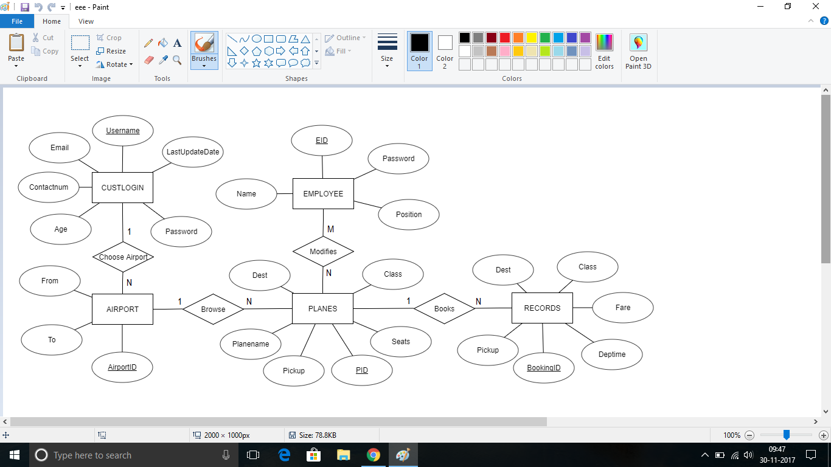

### Database Schema

***Database: airline***

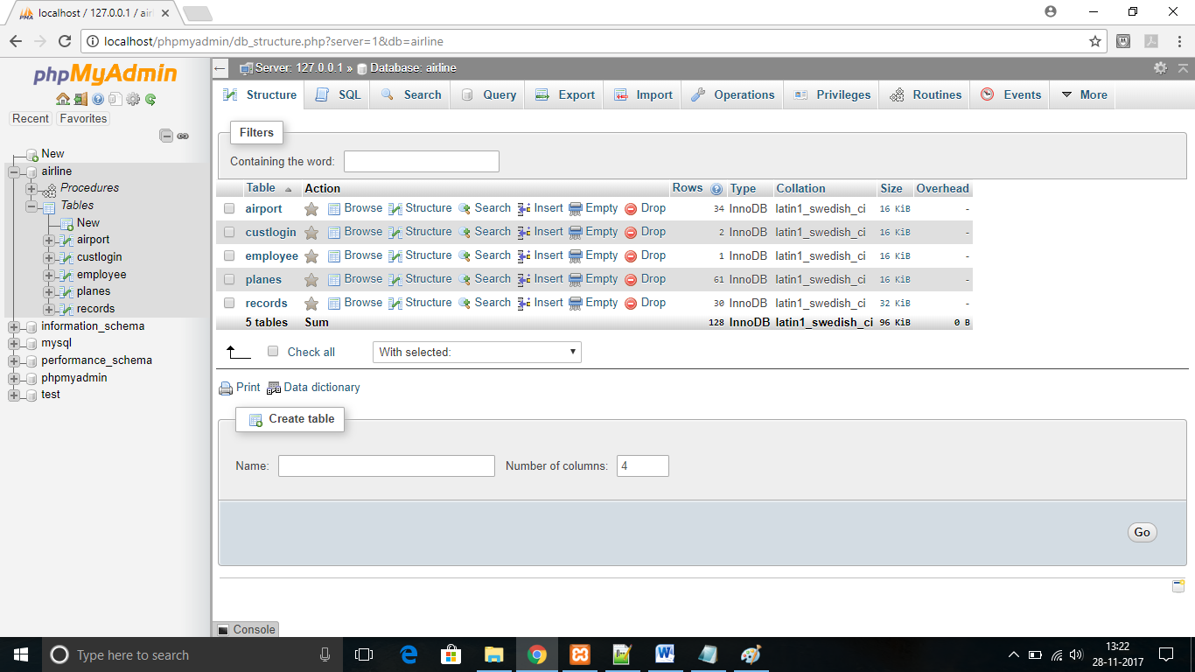

***Table : airport***

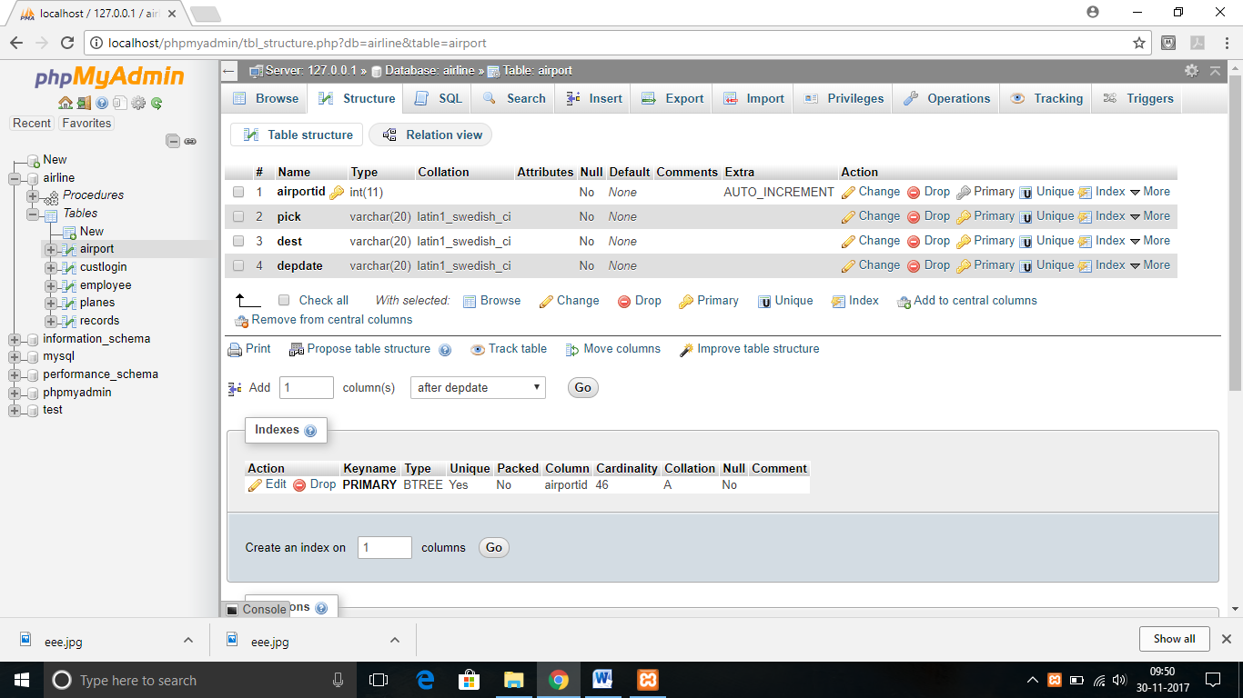

***Table: custlogin***

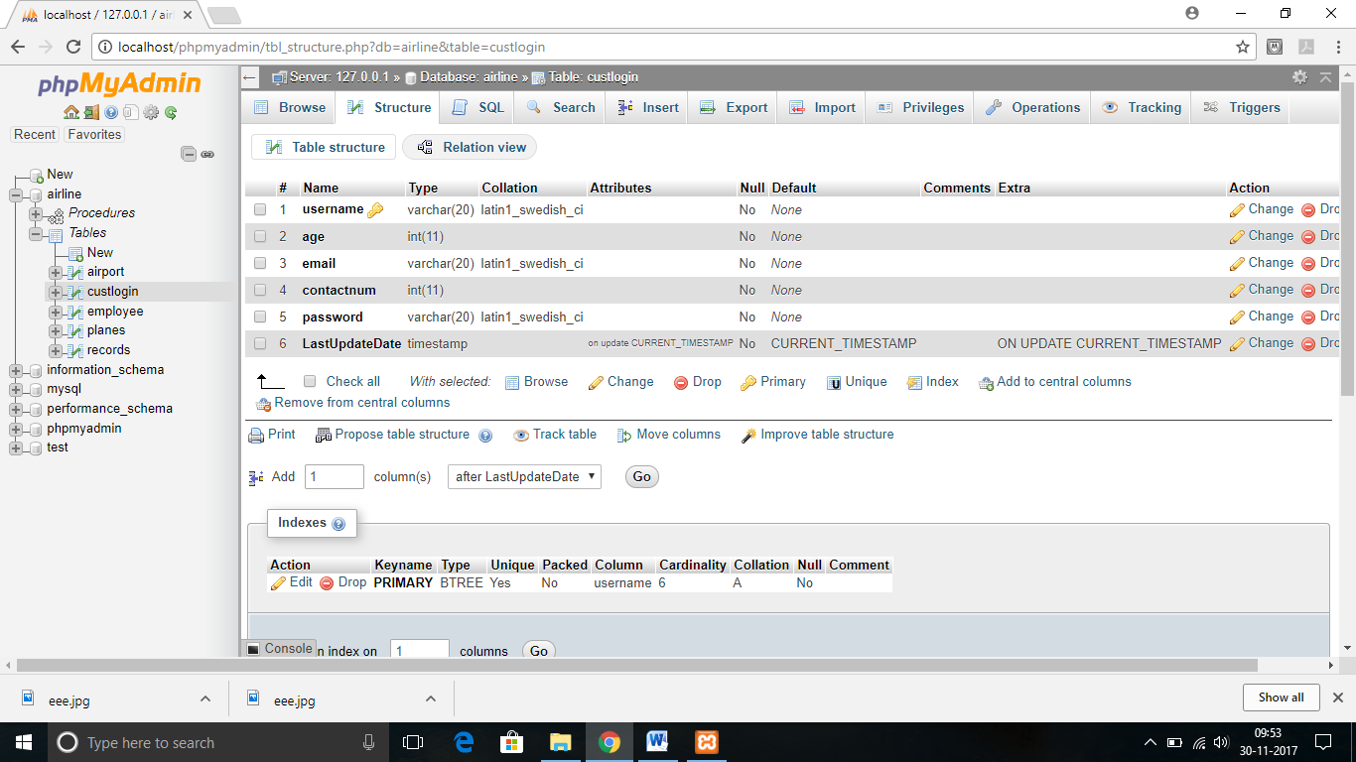

***Table : employee***

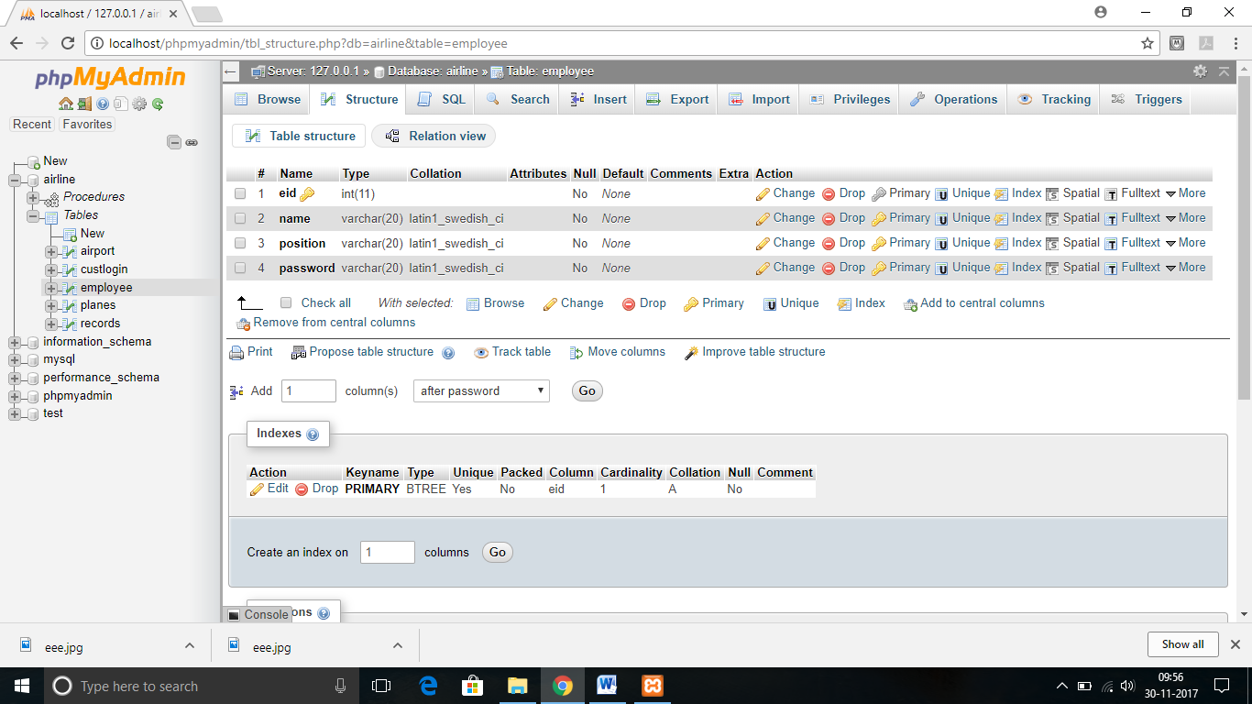

***Table: Planes***

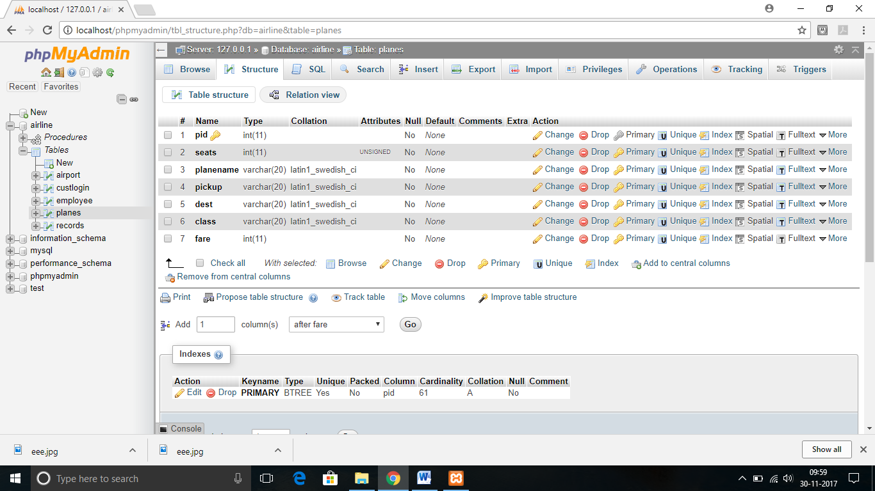

***Table: Records***

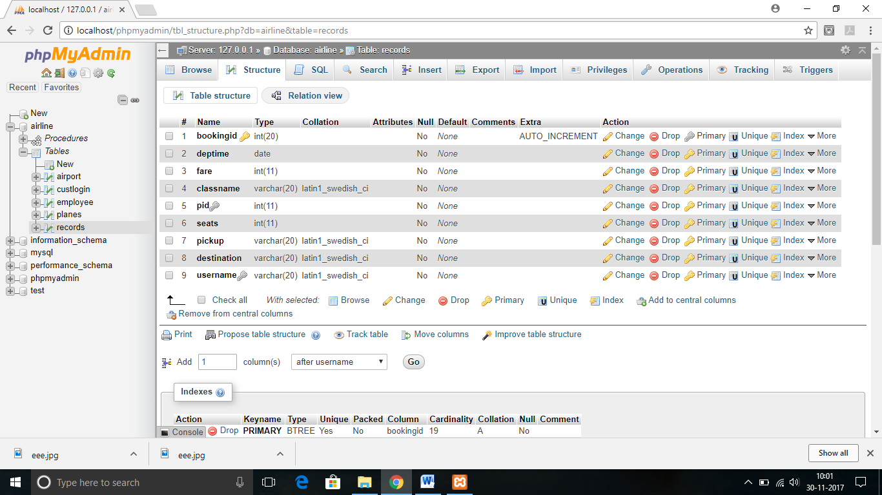

**3.1.3 Relational Schema**

***Database: Airlines***

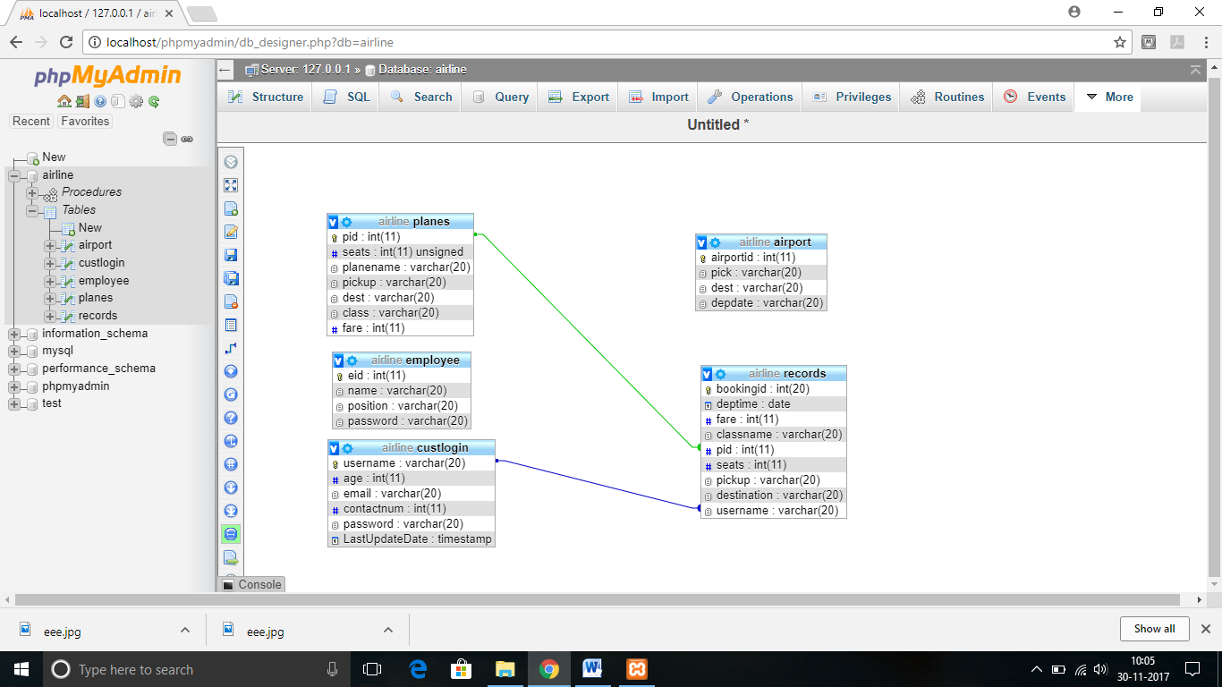

### Database Normalization

### First Normal Form

All the Relations are designed in such a way that it has no repeating groups. Hence all tables are in 1st Normal Form.

### Second Normal Form

A relation is said to be in second normal form if it is already in first normal form and it has no partial dependency. All the tables in the database are designed in such a way that there is no partial dependency. Hence all tables are in 2nd Normal Form.

### Third Normal Form

A relation is said to be in third normal form if it is already in 1st and 2nd Normal Form and has no transitive dependency. All the tables in the database are designed in such a way that there is no transitive dependency. Hence all tables are in 3rd Normal Norm.

### User Interface

The User Interface of the Airline Reservation System(Travel With Comfort) is divided into two parts:

1. User Module - For the users of the airlines

2. Admin Module – For the admin/owner(employee) of the airlines

### User Registration Module

## User Registration:

Figure 3.1 User Registration

**User Login:** 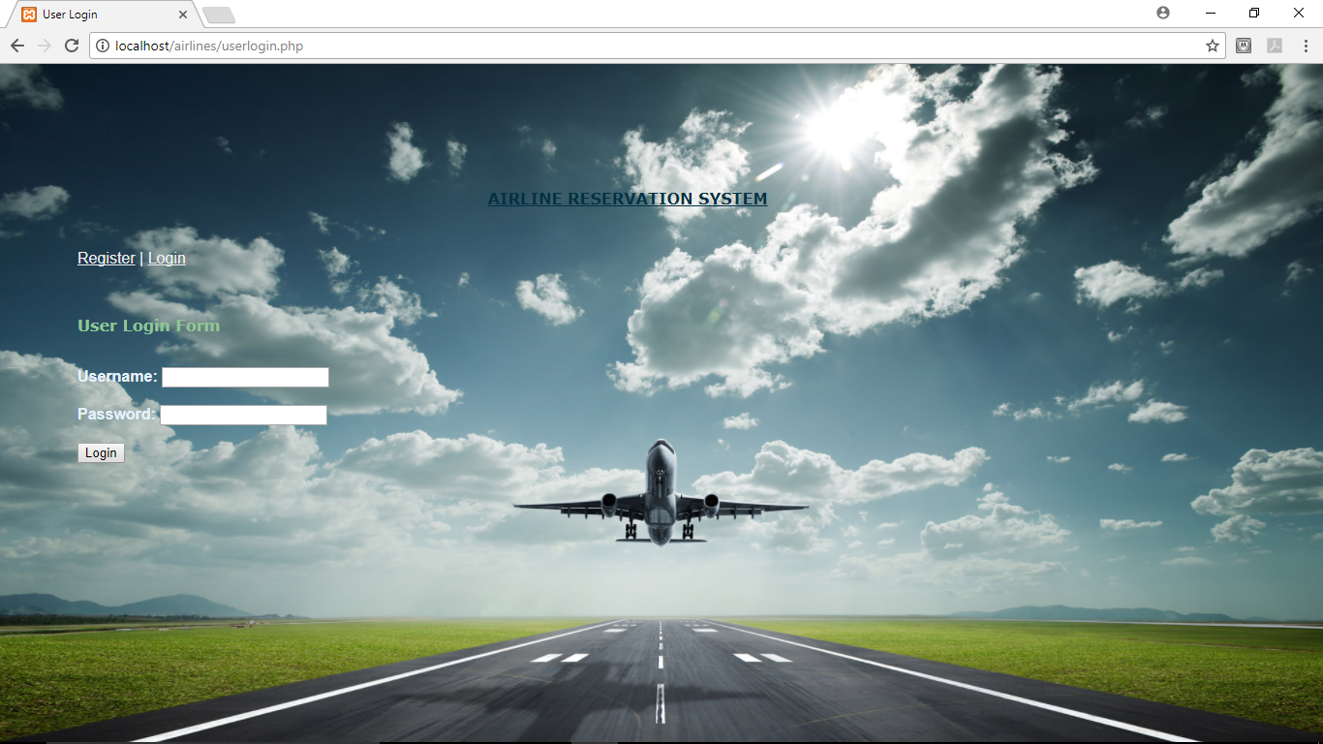

Figure 3.2 User Login

### User Flight Search Module:

**User Flight Search:**

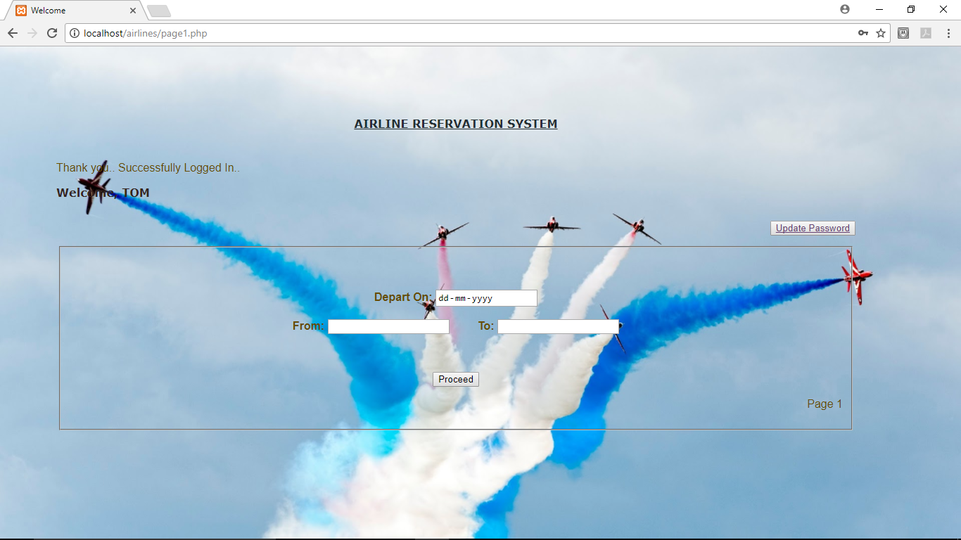

Figure 3.3User Flight Search

**Available Flights:**

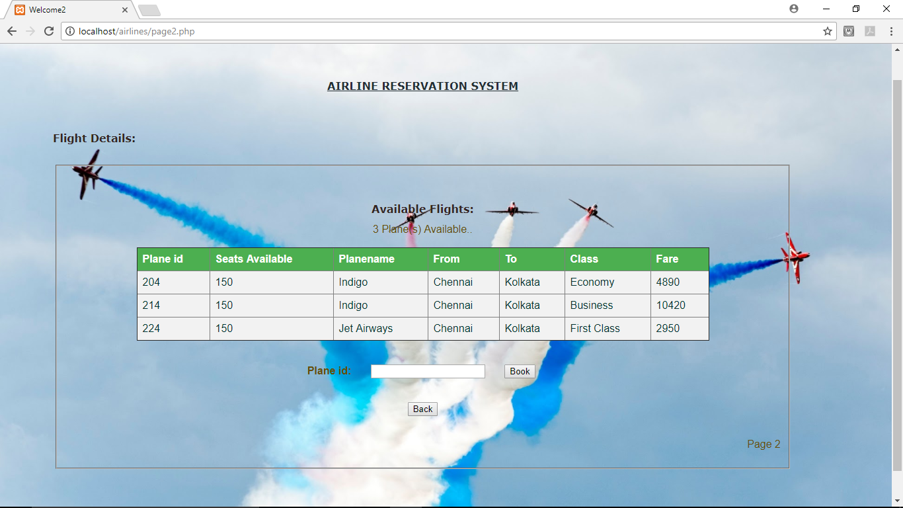

Figure 3.4 Available Flights

**Booking Details**

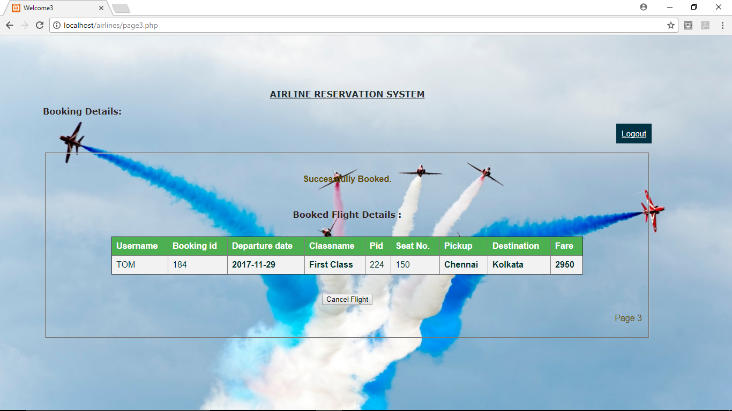

Figure 3.5 Booking Details

**Cancel Flights:**



Figure 3.6 Cancel Flights

### Admin Registration Module:

**Admin Registration:**

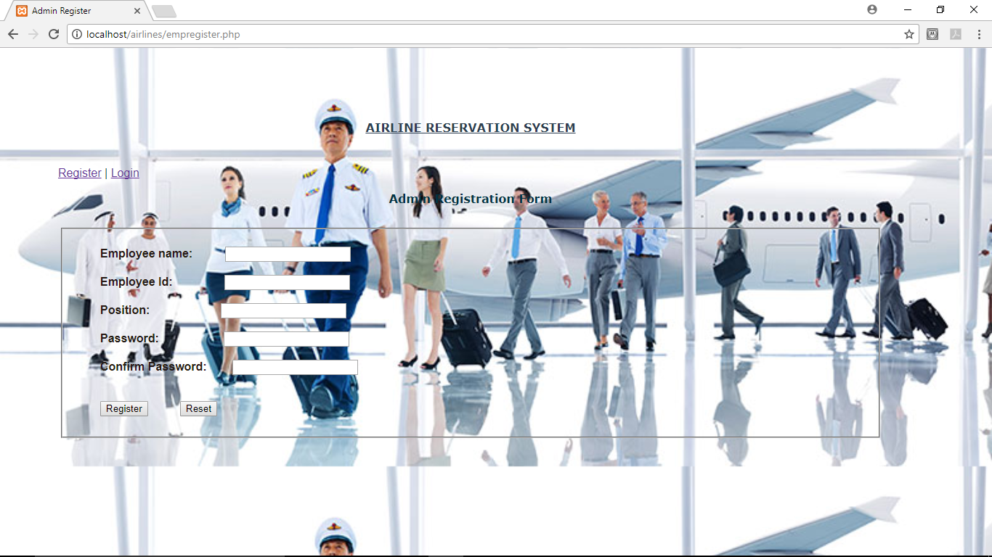

Figure 3.7 Admin Registration

**Admin Login:**

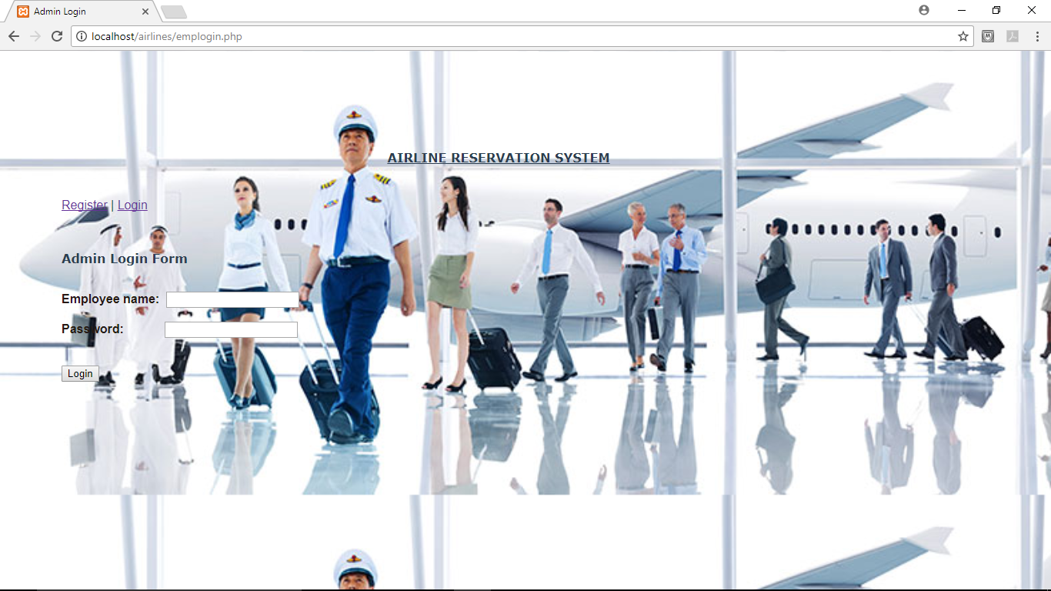

Figure 3.8 Admin Login

### Admin Operations Module:

**Insert New Flights:**

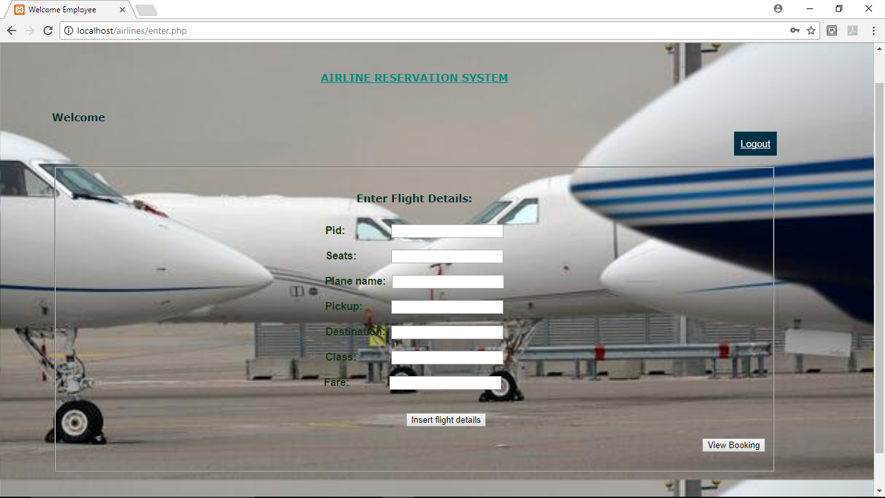

Figure 3.9 Insert New Flights

**View Booking Details:**

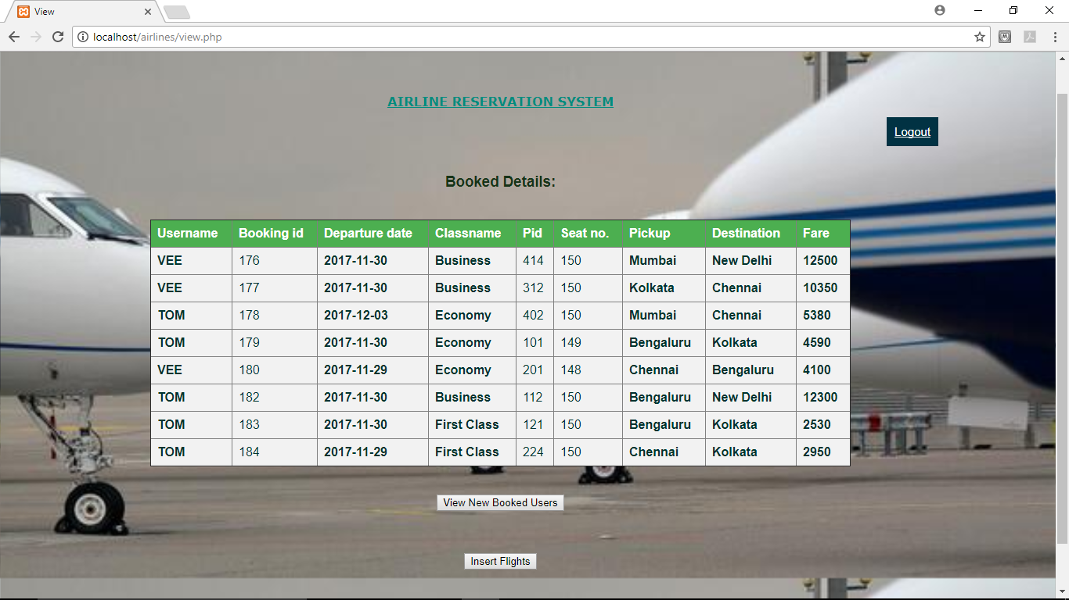

Figure 3.10 View Booking Details

**Filter Search:**

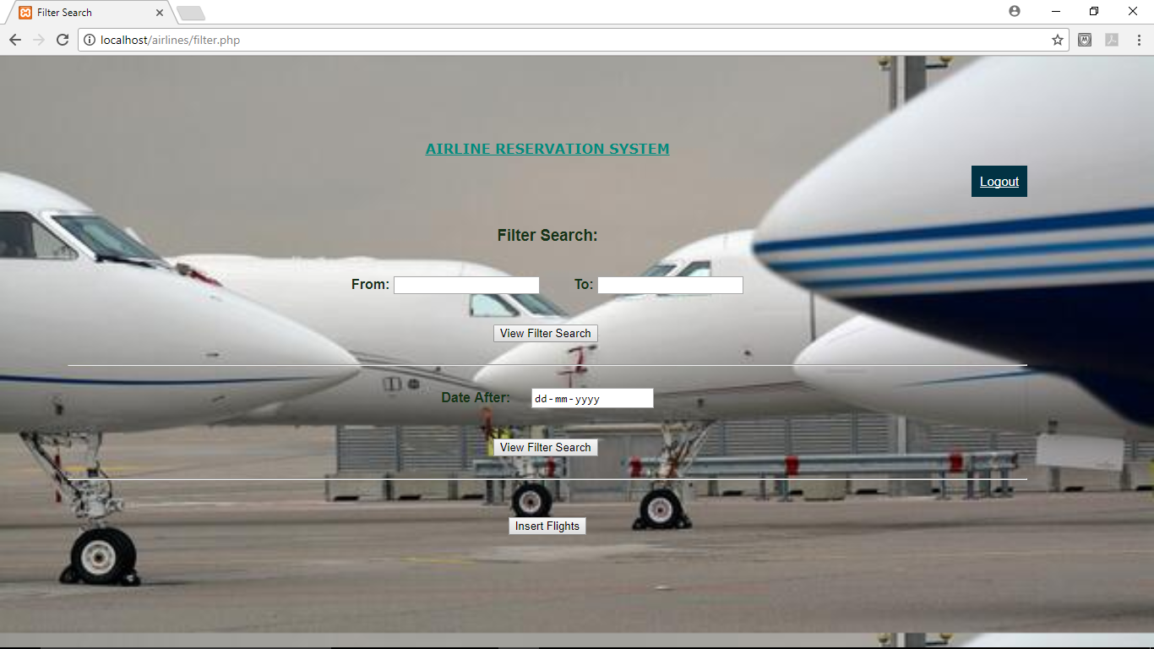

Figure 3.11 Filter Search Booking Details

# 

# CHAPTER 4

## IMPLEMENTATION

### User Registration Module

|  |  |
| --- | --- |
| **Process Name** | **: User Registration** |
| Process Number | : 1.1 |
| Input | : Username |
|  | : Email |
|  | : Contact |
|  | : Age  : Password  : Confirm Password |
| Output | : Status Message |
| Error Condition | : Username Already Exists |
|  | : Passwords do not match  : All Fields are Required |

|  |  |
| --- | --- |
| **Process Name** | **: User Login** |
| Process Number | : 1.2 |
| Input | : Username  : Password |
| Output | : Status Message |
| Error Condition | : Invalid Username or Password |
|  | : All Fields are Required |

### User Flight Search Module

|  |  |
| --- | --- |
| **Process Name** | **: User Flight Search** |
| Process Number | : 2.1 |
| Input | : Depart On |
|  | : From |
|  | : To |
| Output | : Status Message |
| Error Condition | : Enter valid date |
|  | : Pickup and Destination cannot be same |

|  |  |
| --- | --- |
| **Process Name** | **: Available Flights** |
| Process Number | : 2.2 |
| Input | : Plane ID |
| Output | : Flight availability |
| Error Condition | : No planes matching |
|  | : Seats completely filled |

|  |  |
| --- | --- |
| **Process Name** | **: Booking Details** |
| Process Number | : 2.3 |
| Output | : Booked flight details |
| Error Condition | : Updating seats unsuccessful |

|  |  |
| --- | --- |
| **Process Name** | **: Cancel Flights** |
| Process Number | : 2.4 |
| Output | : Successfully cancelled |
| Error Condition | : Flight was not cancelled |

### Admin Registration Module

|  |  |
| --- | --- |
| **Process Name** | **: Admin Registration** |
| Process Number | : 3.1 |
| Input | : Employee Name |
|  | : Employee ID |
|  | : Position |
|  | : Password  : Confirm Password |
| Output | : Status Message |
| Error Condition | : Passwords do not match |
|  | : Employee name already exists |
|  | : All fields are Required |

|  |  |
| --- | --- |
| **Process Name** | **: Admin Login** |
| Process Number | : 3.2 |
| Input | : Employee Name  : Password |
| Output | : Status Message |
| Error Condition | : Invalid Username or Password |
|  | : All fields are Required |

### Admin Operations Module

|  |  |
| --- | --- |
| **Process Name** | **: Insert New Flights** |
| Process Number | : 4.1 |
| Input | : Plane ID |
|  | : PlaneName |
|  | : Seats  : Pickup  : Destination  : Class  : Fare |
| Output | : Status Message |
| Error Condition | : Flight Already Exists |
|  | : All fields are Required |

|  |  |
| --- | --- |
| **Process Name** | **: View Booked Details** |
| Process Number | : 4.2 |
| Output | : Booked Flights Details |
| Error Condition | : Query error |

|  |  |
| --- | --- |
| **Process Name** | **: Filter Search** |
| Process Number | : 4.3 |
| Input | : Date After |
|  | : From |
|  | : To |
| Output | : Booked Flight Details |
| Error Condition | : No flights booked |

***Stored Procedure:***

The Stored procedure implemented in the project helps users to register and cancel flights.

Also it is implemented for the admin to view the flights that have already been booked by the users and also to view the cancelled flights. When the admin clicks on ‘View New Booked Users’, the admin can view all the users who have recently booked.

***Trigger:***

The trigger is implemented in such a way that the username entered by the customer is turned into capitals so that when the user logins, he has to login with the username with the capital letters.

Also, the trigger is used to record the time and date at which the last password was changed.

# CHAPTER 5

## SOURCE CODE

**Sample Source code to display the available flights and book options:**

**Filename: page2.php**

**<?php**

**session_start();**

**if(!isset($_SESSION['sess_aid']) && !isset($_SESSION['sess_user'])){**

**header("location:page1.php");**

**exit();**

**} else {**

**?>**

**<!doctype html>**

**<html>**

**<head>**

**<title>Welcome2</title>**

**<link rel="stylesheet" type="text/css" href="page.css">**

**<style>**

**table {**

**border-collapse: collapse;**

**width: 80%;**

**color: #00332E;**

**}**

**th, td {**

**text-align: left;**

**padding: 8px;**

**}**

**tr:nth-child(even){background-color: #f2f2f2}**

**tr:nth-child(odd){background-color: #f2f2f2}**

**th {**

**background-color: #4CAF50;**

**color: white;**

**}**

**</style>**

**</head>**

**<body>**

**<center><h1><u> AIRLINE RESERVATION SYSTEM </u></h1></center>**

**<br><br><h2>Flight Details:</h2><br>**

**<form action="" method="POST">**

**<legend>**

**<fieldset>**

**<center>**

**<br><br>**

**<h2>Available Flights: </h2>**

**<?php**

**$aid=$_SESSION['sess_aid'];**

**$con=@mysqli_connect('localhost','root','','airline') or die(mysql_error());**

**$sql="SELECT p.pid,p.seats,p.planename,p.pickup,p.dest,p.class,p.fare FROM planes p, airport a WHERE p.pickup=a.pick AND p.dest=a.dest AND a.airportid=$aid";**

**if($result=mysqli_query($con,$sql)){**

**$numrows=mysqli_num_rows($result);**

**if($numrows > 0){**

**echo $numrows." Plane(s) Available..";**

**echo "<br><br><table border='1'>";**

**echo "<tr>";**

**echo "<th>Plane id</th>";**

**echo "<th>Seats Available</th>";**

**echo "<th>Planename</th>";**

**echo "<th>From</th>";**

**echo "<th>To</th>";**

**echo "<th>Class</th>";**

**echo "<th>Fare</th>";**

**//echo "<th>Action</th>";**

**echo "</tr>";**

**while($row=mysqli_fetch_assoc($result)){ ?>**

**<?php echo "<tr>";?>**

**<td><?php echo $row['pid'];?></td>**

**<td><?php echo $row['seats'];?></td>**

**<td><?php echo $row['planename'];?></td>**

**<td><?php echo $row['pickup'];?></td>**

**<td><?php echo $row['dest'];?></td>**

**<td><?php echo $row['class'];?></td>**

**<td><?php echo $row['fare'];?></td>**

**<?php $seats=$row['seats'];?>**

**<?php echo "</tr>";?>**

**<?php**

**}**

**echo "</table><br><br>";**

**?><b> Plane id: &ensp; &ensp; </b><input type="text" name="pid"> &ensp; &ensp;**

**<input type="submit" value="Book" name="book" />**

**<?php**

**}**

**mysqli_free_result($result);**

**}**

**else{**

**echo "No planes matching your requirements were found.";**

**}**

**$user=$_SESSION['sess_user'];**

**if(isset($_POST["book"])){**

**if(!empty($_POST['pid'])){**

**$pid=$_POST['pid'];**

**$con=@mysqli_connect('localhost','root','','airline') or die(mysql_error());**

**if ($seats==='0'){**

**?>**

**<script>**

**window.alert('Seats completely filled.. Press Back..');**

**window.history.back();**

**</script>**

**<?php**

**}**

**else{**

**$sql="INSERT INTO records(deptime,fare,classname,pid,seats,pickup,destination,username) SELECT a.depdate,p.fare,p.class,$pid,p.seats,a.pick,a.dest,c.username FROM planes p,airport a,custlogin c WHERE p.pickup=a.pick AND p.dest=a.dest AND a.airportid='$aid' AND c.username='$user' AND pid='$pid'";**

**if ($result=mysqli_query($con, $sql)) {**

**$_SESSION['sess_user']=$user;**

**$_SESSION['sess_aid']=$aid;**

**header("Location: page3.php");**

**} else {**

**echo "Error: " . $sql . "<br>" . mysqli_error($con);**

**}**

**mysqli_close($con);}**

**}}}**

**?><br><br><br>**

**<input type="button" value="Back" onclick="location.href='page1.php';" /><br><br>**

**</center>**

**<p align="right"> Page 2 </p>**

**</fieldset>**

**</legend>**

**</form>**

**</body>**

**</html>**

***Triggers:***

**CREATE TRIGGER `CAPITAL` BEFORE INSERT ON `custlogin`**

**FOR EACH ROW SET NEW.username=UPPER(NEW.username)**

**CREATE TRIGGER `Last_Password` BEFORE UPDATE ON `custlogin`**

**FOR EACH ROW BEGIN**

**SET NEW.LastUpdateDate = NOW();**

**END**

## *Stored Procedure:*

## User Registration Insert Data:

CREATE PROCEDURE insertData (username varchar(20), age int(11), email varchar(20), contactnum int(11), password varchar(20))

BEGIN

INSERT INTO custlogin(username,age,email,contactnum,password)VALUES(username,age,email,contactnum,password);

END

# CHAPTER 6

## CONCLUSION AND FUTURE WORK

The Airline Reservation System is a great improvement over the manual system which uses lots of manual work and paper. The computerization of the system speeds up the process. This system was thoroughly checked and tested with dummy data and found to be very reliable.

### Advantages

* The Airline Reservation System is fast, efficient and reliable.
* Avoids data redundancy and inconsistency
* Web-based
* Eradicates conflicts between the employees and the customers
* Number of personnel required is considerably less
* Provides more security and integrity to data

### Future Enhancements

The Airline Reservation System can be enhanced by including more functionality like entering Seat details, Track the number of trips , maintain Customers Feedback, Reports, Billing etc.

We can further add an improvised booking system which far more efficient and reliable.

# BIBLIOGRAPHY

**BOOK REFERENCES:**

* Learn to Code HTML and CSS: Develop and Style Websites (Web Design Courses) 1st, Kindle Edition by Shay Howe
* *PHP 6 and MySQL 5* - Larry Ullman

**WEBSITE REFERENCES:**

**HTML Learning:**

* <https://www.codecademy.com/>
* <https://dash.generalassemb.ly/>
* <https://www.w3schools.com/>

**PHP Learning:**

* [http://www.tutorialspoint.com/php/](https://www.php.net)
* <https://killerphp.com>
* <https://www.w3schools.com/>